JAVA SCRIPT

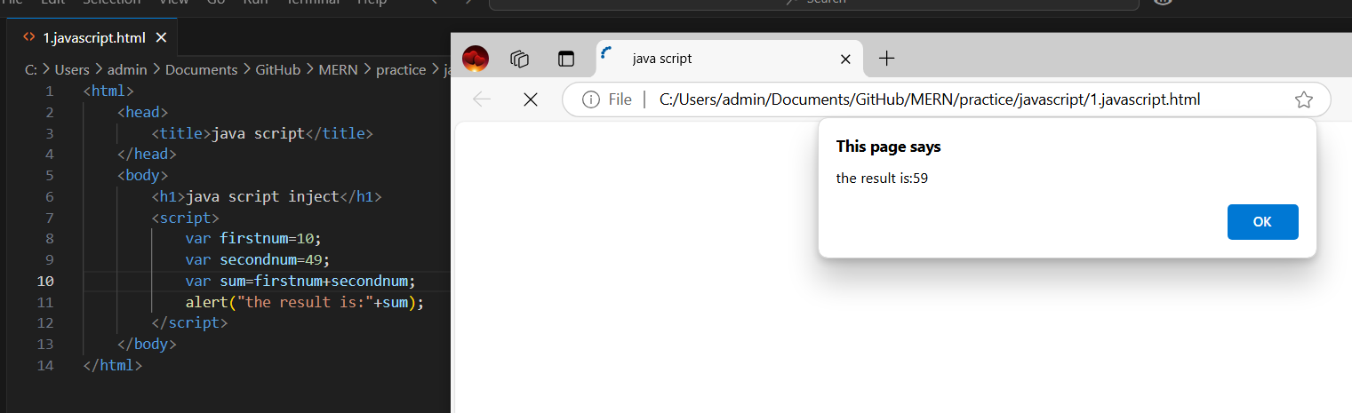

1.IMG

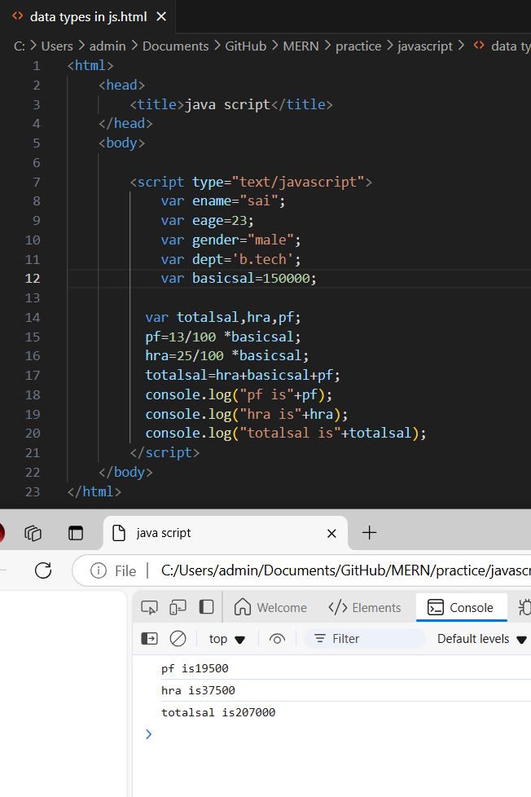

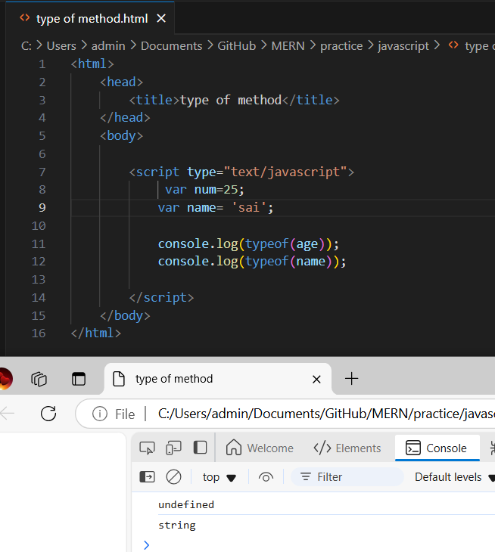

**IMG-TYPE OF METHOD**

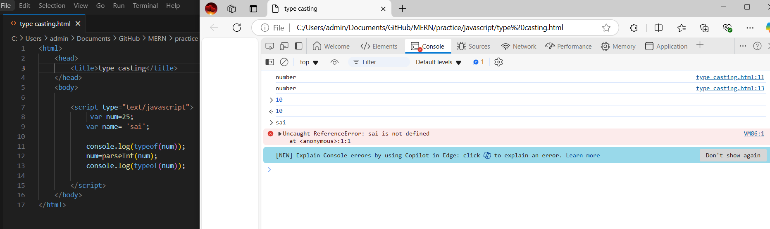

**IMG-TYPE CASTING**

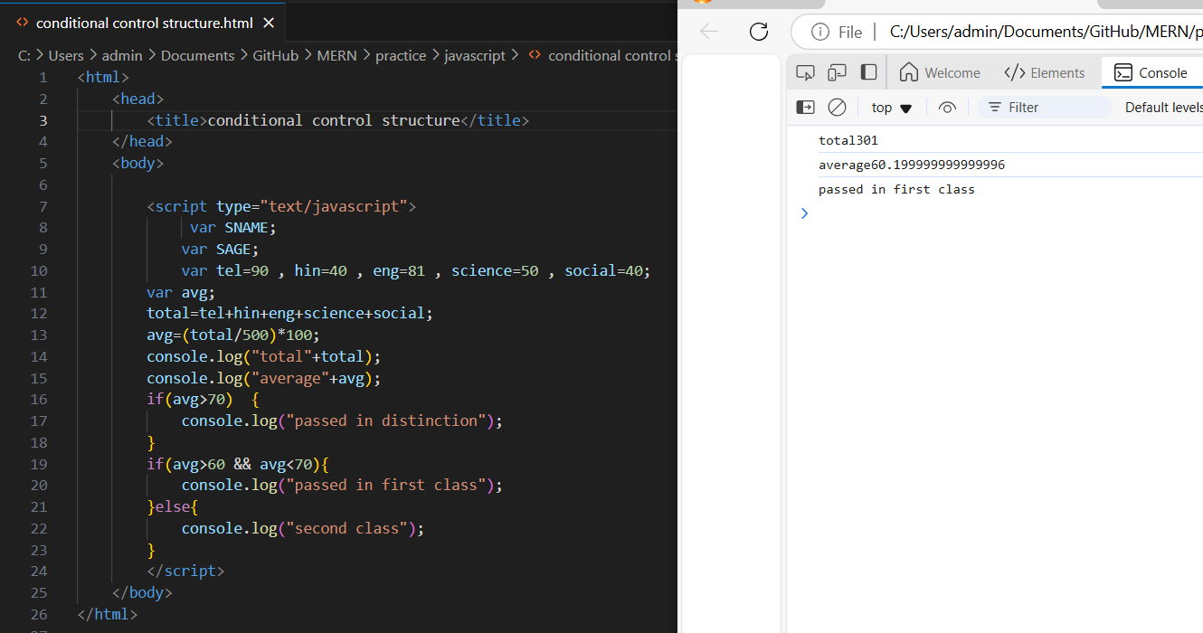

**IMG-CONDITIONAL CONTROL STRUCTURE**